

**CURRENCY CONVERTER SYSTEM USING PYTHON**

**A MINI-PROJECT REPORT**

***Submitted By:***

**Muskaan Goel -ENG18CS0177**

**Muskaan Sinha -ENG18CS0178**

**Lysetti Lakshmi Poojitha -ENG18CS0150**

**Meghana Shree M -ENG18CS0165**

***of***

**BACHELOR OF TECHNOLOGY**

***in***

**DEPARTMENT OF COMPUTER SCIENCE & ENGINEERING *at***

**DAYANANDA SAGAR UNIVERSITY**

**SCHOOL OF ENGINEERING, BANGALORE-560068**

**5TH SEMESTER**

**(Course Code: 16CS305)**

**OBJECT ORIENTED PROGRAMMING**

**DAYANANDA SAGAR UNIVERSITY**



**CERTIFICATE**

This is to certify that the Object Oriented Programming Mini-Project report entitled **“CURRENCY CONVERTER SYSTEM USING PYTHON ”** being submitted by______________________to Department of Computer Science and Engineering, School of Engineering, Dayananda Sagar University, Bangalore, for the 5thsemester B.Tech C.S.E of this university during the academic year

2020-2021.

***Date***:___________ ____________________________ ***Signature of the Faculty in Charge***

____________________________

***Signature of the Chairman***

**TABLE OF CONTENTS**

Contents Page No.

| 1.TITLE | 4 |
| --- | --- |
| 2.ABSTRACT | 5 |
| 3.INTRODUCTION  3.1Problem Statement  3.2Objectives of the Project | 6-7 |
| 4.BODY | 8 |
| 5.ALGORITHM | 9 |
| 6.FLOWCHART | 10 |
| 7.ADVANTAGES | 11 |
| 8.CONCLUSION | 12 |

**1.TITLE**

**CURRENCY CONVERTER USING PYTHON**

Python is a very versatile programming language. Python is being used in almost each mainstream technology and one can develop literally any application with it. Let’s see a Python program to convert the currency of one country to that of another country. To use this service, one must need the API key

The currency converter project in python requires you to have basic knowledge of python programming and the pygame library.

* tkinter – For User Interface (UI)
* requests – to get url

To install the tkinter and requests library, type the following code in your terminal:

1.pip install tkinter

2.pip install requests

**2.ABSTRACT**

A currency converter is software code that is designed to convert one [currency](https://en.wikipedia.org/wiki/Currency) into another in order to check its corresponding value. The code is generally a part of a web site or it forms a [mobile app](https://en.wikipedia.org/wiki/Mobile_app) and it is based on current market or bank [exchange rates](https://en.wikipedia.org/wiki/Exchange_rate).

In order to convert one currency into another, a user enters an amount of money (e.g. '1000') and chooses the currency he/she wishes to check the monetary value of (e.g. '[United States Dollar](https://en.wikipedia.org/wiki/United_States_Dollar)'). After that, the user selects one, or sometimes several other currencies, he/she would like to see the result in. The [application software](https://en.wikipedia.org/wiki/Application_software) then calculates and displays the corresponding amount of [money](https://en.wikipedia.org/wiki/Money).

Currency converters aim to maintain real-time information on current market or bank exchange rates, so that the calculated result changes whenever the value of either of the component currencies does. They do so by connecting to a [database](https://en.wikipedia.org/wiki/Database) of current currency exchange rates.

In finance,an exchange rate between two currencies is the rate at which one currency will be exchanged for another.It is a useful tool which gives us the value of certain amount of one currency to be converted into a different currency.It is also regarded as the value of one country’s currency in terms of another currency.In this project we are going to display a web window in which currency options are given and the conversion value is displayed in the next Window.

**3. INTRODUCTION**

**3.1PROBLEM STATEMENT**

The introduction of a currency converter will reduce the amount of time it takes to serve clients who are looking to invest overseas or perhaps are going on holiday and they need local currency to buy things. Some of the issues that will come with a currency converter is that it will have to be updated regularly as the world’s currencies constantly fluctuate.

The converter must also be aesthetically pleasing and not look like it has been coded at the last minute with inequalities in the design. If it does not look good the user might have second thoughts about trusting the amounts that the program comes out with.The converter must be as user friendly as possible and easy to use if the converter is too complex to learn then the user will be put off using the converter. Another important aspect of the converter is that it must have variety so that it can be used for multiple currency conversions.

**3.2 OBJECTIVES OF THE PROJECT**

Currency Converter is a calculator or a software or a tool that converts the quantity or value of one currency into the relative quantities or values of other currencies to check its corresponding value such as dollars to euros. It is an electronic program that allows for the quick conversion of currencies. Converters use the most recent prices to convert in the foreign exchange market. When currency converters use online it is usually free of charge. It stores the most recent market valuations of the world’s currencies which allows individuals to compare the value of one currency against those of others in the database.

Currency Conversion can also be determined by contacting a local bank and asking for exchange rates. Main aim for this currency converter is to maintain real-time information on current market or bank exchange rates, So it will be helpful to calculate changes of the result whenever the value of either of the component currencies does.

**4. BODY**

Here in this project we are using a currency convertor to convert currencies in python programming language. We are emphasising on concepts of oops. To run the code in python we have downloaded various packages. We have used a URL to connect our code to a website which updates the currency values which changes each day. In this project we have used a few countries not all as this is just a mini project.

The output or the entered amount can be entered in four decimal places. Currencies can be converted in both ways, example USD->INR &

INR->USD, all changes happen in a click of a button. All data has been taken from that particular URL. Our project also works as an app. The code runs in loops and depends on a real time currency convertor.

We have chosen python as it is versatile, easy to use and fast. It has all the libraries and it is open source, it increases portability and has good productivity.

**5. ALGORITHM**

**1. Real-time Exchange rates**

* To get real-time exchange rates, we will use: <https://api.exchangerate-api.com/v4/latest/USD>
* Base – USD: It means we have our base currency USD. Which means to convert any currency we have to first convert it to USD then from USD, we will convert it in whichever currency we want.
* Date and time: It shows the last updated date and time.
* Rates: It is the exchange rate of currencies with base currency USD.

#### 2. Import the libraries:

* For this project based on Python, we are using the tkinter and requests library. So we need to import the library.

#### 3. Create the CurrencyConverter class:

* Now we will create the CurrencyConverter class which will get the real time exchange rate and convert the currency and return the converted amount.
* create the constructor of class.

**4. Convert() method:**

This method takes following arguments:

* From_currency: currency from which you want to convert.
* to _currency: currency in which you want to convert.
* Amount: how much amount you want to convert.
* And returns the converted amount

**6.FLOWCHART**

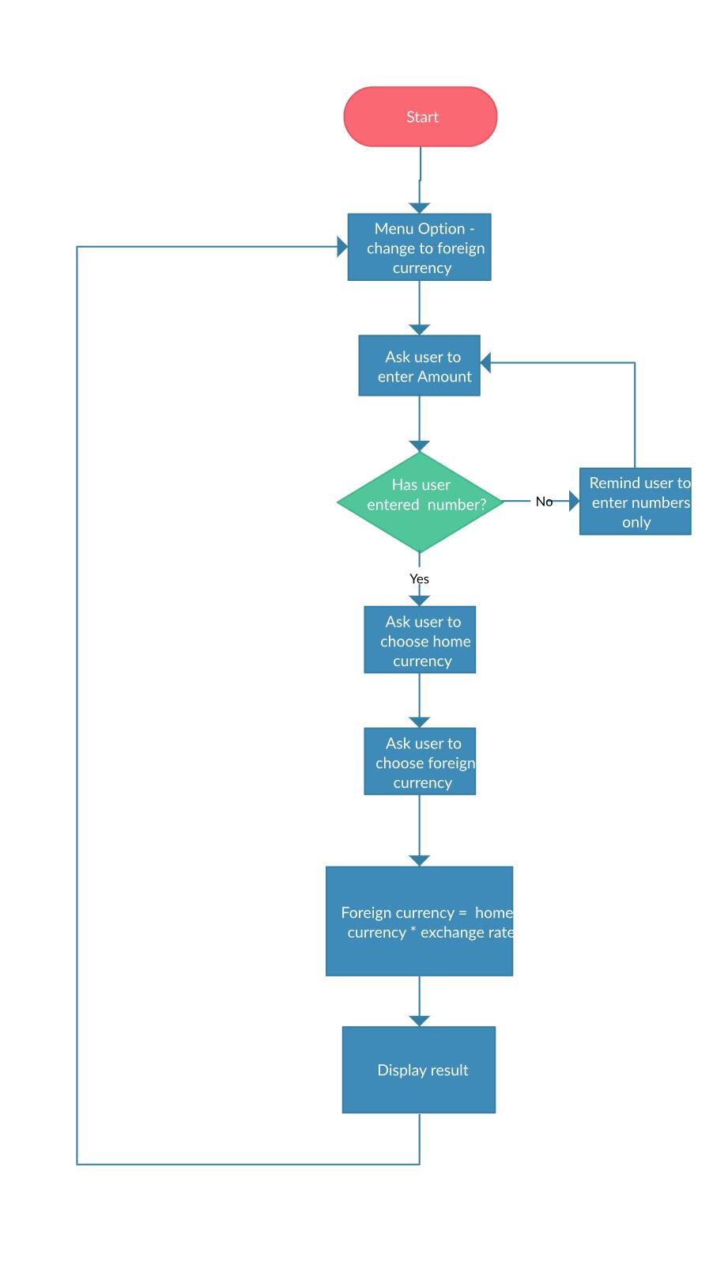

**7. Advantages**

* Its works fast
* Is simple to use.
* Helps for faster conversions
* Great use for exchange.

**8.CONCLUTION**

Currency converters usually display a value that is not biased towards buying or selling. This is useful when:

* Estimating the value of goods or services
* Basic accounting and invoicing
* Preparing financial plans and reports

The currency conversion software calculates the rates as decimal point numbers with typically 4 decimals after the comma. Some may calculate the conversion rates with more decimals internally but only 4 are displayed. This is related to precision, software internalization and how the international markets work, where most conversions have 4 decimal places, although some currency pairs also have 5. Most currency converters use up to 4.

The future scope for currency conversion is that as technological advancements take place, it’ll become much more easier for people to travel to different places or invest in businesses worldwide. So, Currency conversion can be a beneficial tool in the future.